Sohaib Ahmad
L1F18BSCS0411
Introduction to Software
Engineering
Assignment 3
University of Central Punjab

Question No.1:
For each of the following system, Draw/Sketch an appropriate software architecture diagram and explain what key functionalities each module will perform. Also suggest appropriate architecture style for each and justify your selection.

A) Library management system having books+ local copies of international journals
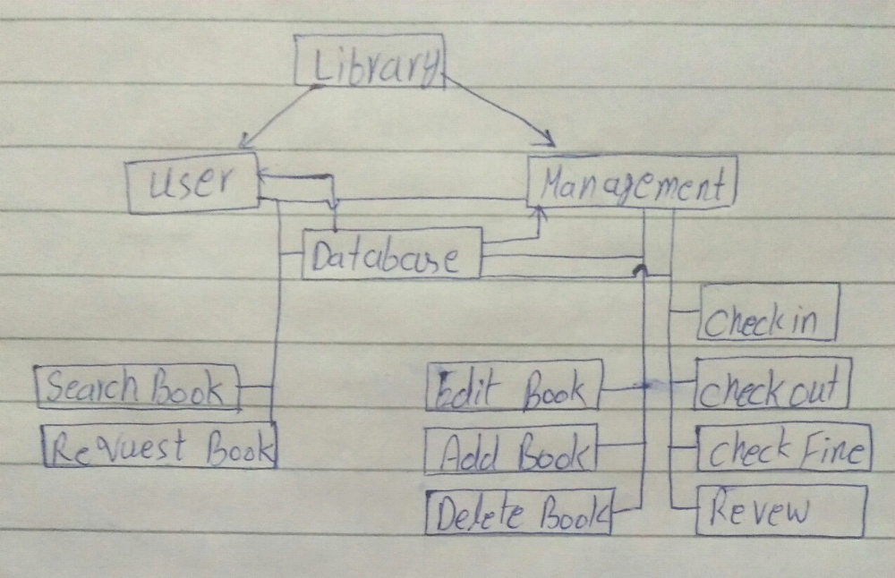
B) Internet based election polling booth system
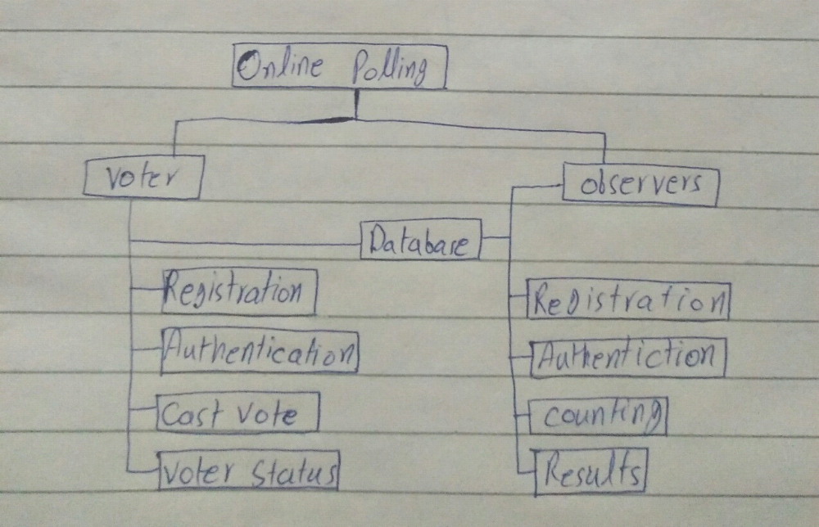
C) Interior design software generating different maps
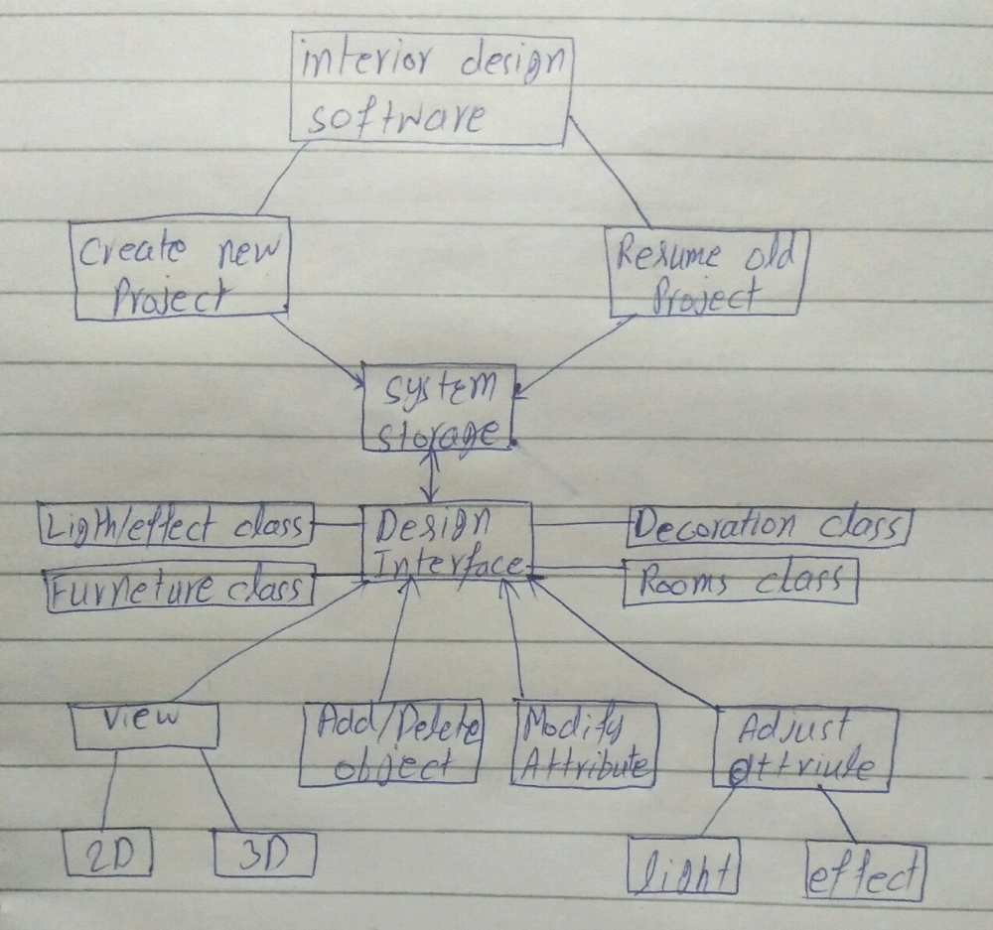

Question No.2:
A) Discuss any three types of coupling. Why content coupling is high from all types of coupling?

Content Coupling:
One component modifies an internal data item of another component.
Common Coupling:
When two classes access the same shared data. For example a global variable can used by different classes.
Control Coupling:
One component passes parameters to control the activity of another component. The controlled component cannot function without direction from the controlling component​.

Content coupling is high from all types:
Because one module can modify the data of another module or control flow is passed from one module to the other module. So, this is the worst from all types of coupling.

B) Discuss any three types of cohesion. Why coincidental cohesion is weak and functional cohesion is high?

Functional Cohesion:
Every essential element for a single computation is contained in the component. A functional cohesion performs the task and functions. It is an ideal situation.
Sequential Cohesion:
An element outputs some data that becomes the input for other element, i.e., data flow between the parts. It occurs naturally in functional programming languages.
Communication Cohesion:
Two elements operate on the same input data or contribute towards the same output data. For example update record int the database and send it to the printer.

Coincidental cohesion is weaker and function is high:
Because elements have no conceptual relationship other than location in source code. Coincidental is accidental and the worst form of cohesion.

C) Why we use sandwiching technique in incremental development? Make graphical representation of sandwiching for three units.

We can try to break a cycle in the uses graph using a technique called sandwiching​
One of the cycle’s units is decomposed into two units, such that one of the new units has no dependencies​.
Sandwiching can be applied more than once, to break either mutual dependencies in tightly coupled units or long dependency chains​.
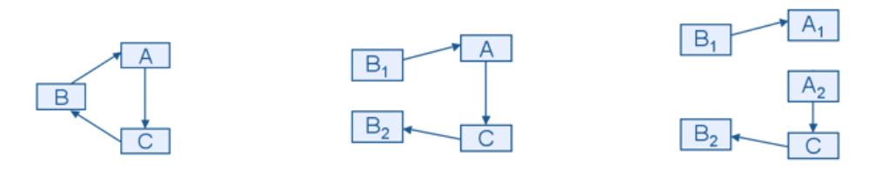

D) In OO design, we use both composition and inheritance. Which is better for OOD? Compare both by providing three characteristics for each.

Inheritance:
When we want to create a new class and there is already a class that includes some of the code that we want, we can derive our new class from the existing class. In doing this, we can reuse the fields and methods of the existing.

Composition:
The composition also provides code re-usability but the difference here is we do not extend the class for this.

In inheritance, we define the class which we are inheriting(super class) and most importantly it cannot be changed at run-time.
Whereas in composition we only define a type which we want to use and which can hold its different implementation also it can change at run-time. Hence, Composition is much more flexible than Inheritance.

Question No.3:
A) How can we reuse design of existing systems?
The systematic use of existing software assets to construct new or modified assets. Software assets in this view may be source code or executable, design templates, or entire software architectures and their components forming a product line or product family.

B) How can we estimate software coding effort based on our design phase activities?

The estimation is a process and this process contains the following steps to reach the estimate, this process is cycling until you reach the final estimate for the project. We use,
Scoping
Decomposition
Sizing
Expert and Peer Review
Estimation Finalization

C) Provide a list of 5 generic UI evaluation questions

How did you first learn about our product?
How likely is it that you could recommend our product to a friend or colleague?
What comes to your mind when thinking about our product?
If review our product/website with a score out of 10, what score would you give us?
Which of our competitors did you consider before choosing us?

D) Explain why a shared data solution is difficult to re-use

As the data shared between different components in this architecture,components access,update,delete,modify the data thus its very difficult to provide updated data to each component which requests the data same for when a component delete a data different components cannot be updated about this info that the data they are accessing is deleted. By accessing and reusing these data, scientists can answer complex research problems that need systemic approaches to knowledge discovery.

Question No.4:
A) Explain three main categories of object oriented design patterns suggested by GOF?
The GoF Design Patterns are broken into three categories:
Recreational Patterns for the creation of objects. It is used to create objects for a suitable class that reuses as a skeleton. These patterns abstract the information process. It makes the design independent from how the objects are compared,viewed & repeated.
B) Describe names of software applications that are using the following user interface design trends. Provide 3 software applications names for each trend.
- Laser Focus
Search engines like google, duckduckgo,
- Minimalism
Apps like Facebook posts,twitter posts
- Content Chunking
Apps like amazon,apple store,google
C) Describe main evaluation criteria that can be applied before prototyping and used during design reviews to the design model.
Answer:
The goal of a prototype is to evaluate an idea.
Define your main goal of the project. Start your initial brainstorming with your team. You may know your design obstacles and need to research solutions. Remember this version will be refined along the way.
Sanctification of user is a must also conformance of the 3 golden rules of user interface design is must.
Any managers, users, researchers etc. should be included for feedback. Edit your design after discussion with partners or stakeholders.
Consult with appropriate entities and make approved revisions. If the outcome is what you agree on, add another feature.

